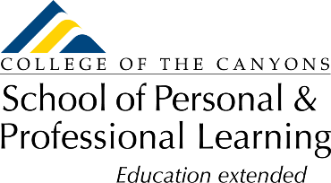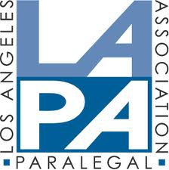
Unlock Your Potential:
Become a “Certified Paralegal”
College of the Canyons is offering study courses for the NALA CP Exam
The courses are noncredit and FREE to California residents!
Course | Dates | # Wks | Days/Times | Modality
NC.PLGL-001  Knowledge | 2/26/24 – 5/06/24 | 10 | Mondays  6:00 – 8:00 pm | LIVE/via Zoom
NC.PLGL-001  Knowledge | 2/26/24 – 5/11/24 | 10 | Online | Online
NC.PLGL-001  Knowledge | 3/18/24 – 5/30/24 | 10 | Online | Online
NC.PLGL-002  Skills | 2/10/24 – 3/30/24 | 8 | Saturdays  9:00 – 11:00 am | LIVE/via Zoom
NC.PLGL-002  Skills | 4/13/24 – 5/25/24 | 7 | Saturdays  9:00 – 11:20 am | LIVE/via Zoom

Location: Virtual/LIVE/via Zoom or Online (Guided Self-study)
Registration: Free to California residents
To Register: www.canyons.edu/freeclasses
Assistance with registration: Call (661) 362-3304 or email freeclasses@canyons.edu

